**Data Encoding**

For data transmission or transmissions, depending on the distance between devices and transmission media, the data must be converted in a form that can be quickly and correctly transmitted. Mostly the information is transmitted in the form of electrical signals. The conversion of data bits into electrical signals cannot be sufficient; instead, there are soon more transmission requirements.

Some transmission requirements are sufficient to signal transitions in the transmitted signal, bandwidth matching of signal and transmission media and proper differentiation in states of received signals. It can meet these requirements, and the data should be converted in a valid format. This conversion is known as data encoding or signal encoding. The data to be sent can be one of the two types.

* Analog Data
* Digital Data

Four types of encoding may be required depending on data, transmission media and distance between sender and receiver. They are

* Analog Data to Analog Conversion
* Analog Data to Digital Conversion
* Digital Data to Analog Conversion
* Digital Data to Digital Conversion

Data is sent in the structure of electrical signals. These electrical signals can have an analog signal (analog waveform), which are continuous and non-discrete. They gradually change from high to low and low to high voltage values or a form of the digital signal represented by discrete voltage levels having abrupt changes in high and low voltage states, as shown in the figure.

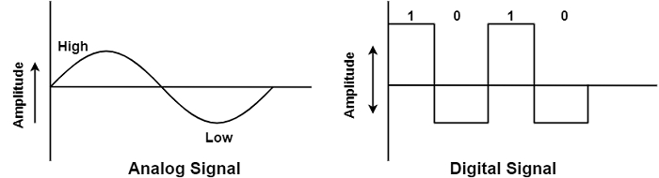

In both the signals, a high voltage indicates 1, and a low indicates '0'. Digital data has a binary format. While converting them to an electrical signal, a positive voltage can be considered '1' and –ve voltage as '0'.

These signals will be digital, but conversion to electrical signals will not be sufficient but has to convert into analog signals if the data is transmitted through telephone lines or satellite. But analog signals have drawbacks like relaying through amplifiers, and transducers may cause linear distortion noise on the channel is called attenuation.

## DIGITAL-TO-DIGITAL CONVERSION

Digital-to-digital encoding is the representation of digital information by a digital signal. When binary 1s and 0s generated by the computer are translated into a sequence of voltage pulses that can be propagated over a wire, this process is known as digital-to-digital encoding.

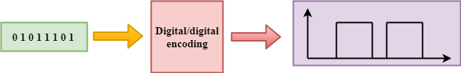

Digital-to-digital encoding is divided into three categories:

* Unipolar Encoding
* Polar Encoding
* Bipolar Encoding

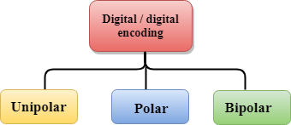

## Unipolar

* Digital transmission system sends the voltage pulses over the medium link such as wire or cable.
* In most types of encoding, one voltage level represents 0, and another voltage level represents 1.
* The polarity of each pulse determines whether it is positive or negative.
* This type of encoding is known as Unipolar encoding as it uses only one polarity.
* In Unipolar encoding, the polarity is assigned to the 1 binary state.
* In this, 1s are represented as a positive value and 0s are represented as a zero value.
* In Unipolar Encoding, '1' is considered as a high voltage and '0' is considered as a zero voltage.
* Unipolar encoding is simpler and inexpensive to implement.

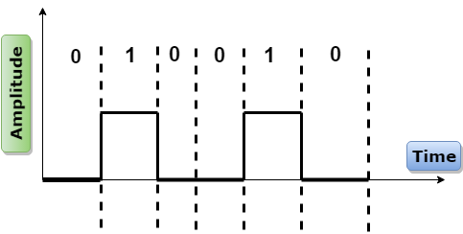

Unipolar encoding has two problems that make this scheme less desirable:

## Polar

* Polar encoding is an encoding scheme that uses two voltage levels: one is positive, and another is negative.
* By using two voltage levels, an average voltage level is reduced, and the DC component problem of unipolar encoding scheme is alleviated.

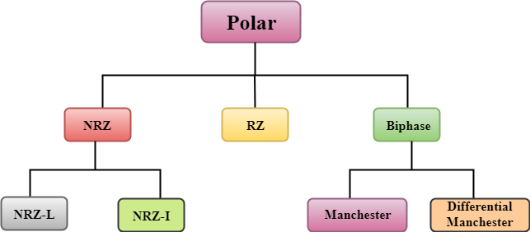

### NRZ

* NRZ stands for Non-return zero.
* In NRZ encoding, the level of the signal can be represented either positive or negative.

**The two most common methods used in NRZ are:**

**NRZ-L:** In NRZ-L encoding, the level of the signal depends on the type of the bit that it represents. If a bit is 0 or 1, then their voltages will be positive and negative respectively. Therefore, we can say that the level of the signal is dependent on the state of the bit.

**NRZ-I:** NRZ-I is an inversion of the voltage level that represents 1 bit. In the NRZ-I encoding scheme, a transition occurs between the positive and negative voltage that represents 1 bit. In this scheme, 0 bit represents no change and 1 bit represents a change in voltage level.

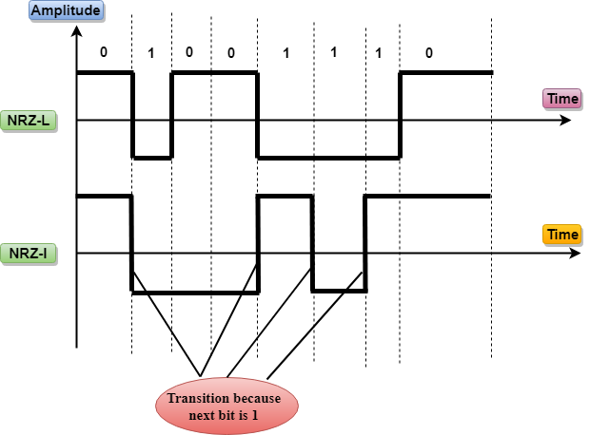

### RZ

* RZ stands for Return to zero.
* There must be a signal change for each bit to achieve synchronization. However, to change with every bit, we need to have three values: positive, negative and zero.
* RZ is an encoding scheme that provides three values, positive voltage represents 1, the negative voltage represents 0, and zero voltage represents none.
* In the RZ scheme, halfway through each interval, the signal returns to zero.
* In RZ scheme, 1 bit is represented by positive-to-zero and 0 bit is represented by negative-to-zero.

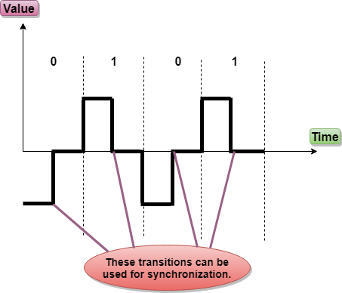

**Disadvantage of RZ:**

It performs two signal changes to encode one bit that acquires more bandwidth.

## Bi-phase Encoding

The signal level is checked twice for every bit time, both initially and in the middle. Hence, the clock rate is double the data transfer rate and thus the modulation rate is also doubled. The clock is taken from the signal itself. The bandwidth required for this coding is greater.

There are two types of Bi-phase Encoding.

* Bi-phase Manchester
* Differential Manchester

### Bi-phase Manchester

In this type of coding, the transition is done at the middle of the bit-interval. The transition for the resultant pulse is from High to Low in the middle of the interval, for the input bit 1. While the transition is from Low to High for the input bit **0**.

### Differential Manchester

In this type of coding, there always occurs a transition in the middle of the bit interval. If there occurs a transition at the beginning of the bit interval, then the input bit is **0**. If no transition occurs at the beginning of the bit interval, then the input bit is **1**.

The following figure illustrates the waveforms of NRZ-L, NRZ-I, Bi-phase Manchester and Differential Manchester coding for different digital inputs.



